Shri Ramswaroop Memorial University

DATA ANALYSIS REPORT||
Pollution Impact of the Russia-Ukraine War & Diwali Crackers .
Session: 2025-26
Course: BTech CS (DS+AI) ---- Data Analytic & Reporting
Submitted To: Deepika Tiwari (IBM Faculty)
Submitted By:
Krishna Awasthi (Roll No: 202410101150074)
Harsh Raj (Roll No: 202410101150098)
Group No: 33,34
Institution: SHRI RAMSWAROOP MEMORIAL UNIVERSITY
- Key Visuals Included|
PM2.5 &C02 Trend
Acute PM2.5 Concentration and level
- Skills Applied|
Python & Pandas Data Analysis
Matplotlib Visualization
Environmental Data Interpretation
Real-world Dataset Cleaning & Processing

Abstract
Global Pollution Dynamics: Analyzing Anthropogenic
and Conflict-Related Emissions
This project presents a quantitative analysis of environmental pollution—specifically PM2.5 and CO2 emissions—resulting from two distinct event types: the annual, human-driven festival of Diwali and the sustained, conflict-driven Russia-Ukraine War.
The primary objective is to compare the magnitude and regional distribution of air quality impact using statistical methods and advanced visualization techniques in Python.
The analysis involved calculating the percentage increase in pollution during each event relative to the baseline "Before" period. It also included a comparison of total CO2 tonnage and a regional breakdown of PM2.5 levels during the war.
This comparative study aims to transform raw environmental data into actionable insights, providing a clear, data-driven perspective on the differing scales of impact from cultural events versus geopolitical conflicts on air quality.

Introduction
The analysis of air pollution is a critical area of environmental science. This report documents an analysis conducted using the Python data science ecosystem to quantify and compare the pollution effects of two major, high-impact events: the Diwali festival and the Russia-Ukraine War.

This project's core objective is to analyze the scale and type of environmental impact from these events, contrasting a concentrated, short-term cultural event with a prolonged, geographically constrained conflict.

The project leverages the Pandas library for data processing and Matplotlib/Seaborn for professional statistical visualization to achieve the following:
- Quantify the relative increase in PM2.5 and CO2 during both events.
- Compare the overall average CO2 tonnage emitted by both events.
- Analyze the PM2.5 concentration and spatial distribution in the most affected Indian States (Diwali) and Ukrainian Regions (War).

Insights and Visualizations
Insight 1: Comparative Percentage Increase in Pollution
This visualization shows the relative pollution shock during each event compared to its respective baseline ("Before" phase).
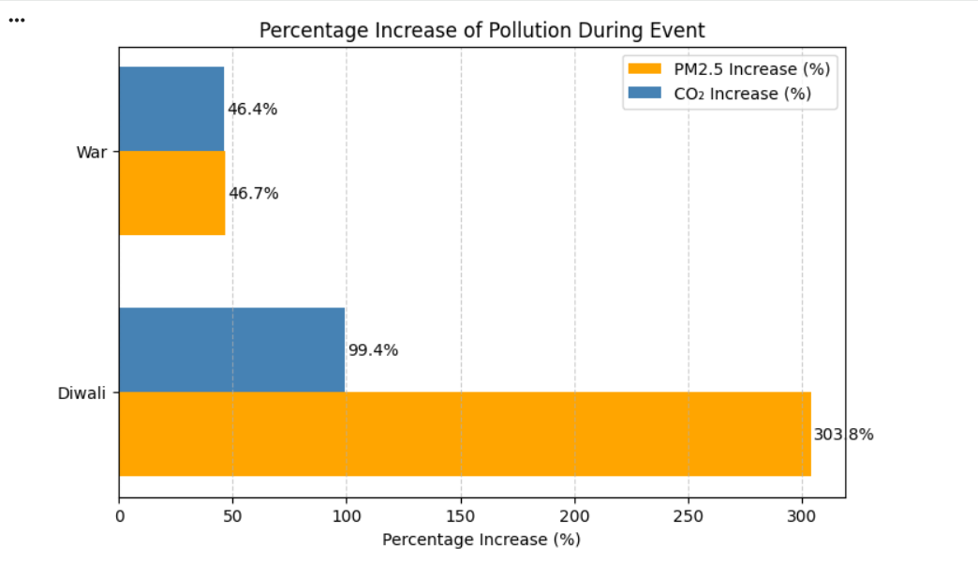
Observation:
- The Diwali festival causes a dramatically higher percentage increase in PM2.5 (303.8%) and CO2 (99.4%) compared to the baseline period, indicating an immense but short-term pollution spike.
- The War causes a significant but much lower relative increase in both PM2.5 (46.7%) and CO2(46.4%), suggesting a sustained, lower-intensity disruption compared to the sharp spike of Diwali.

Insight 2: Magnitude Comparison of Average CO2 Emissions
This chart compares the actual average CO2 tonnage associated with the entire duration of each event.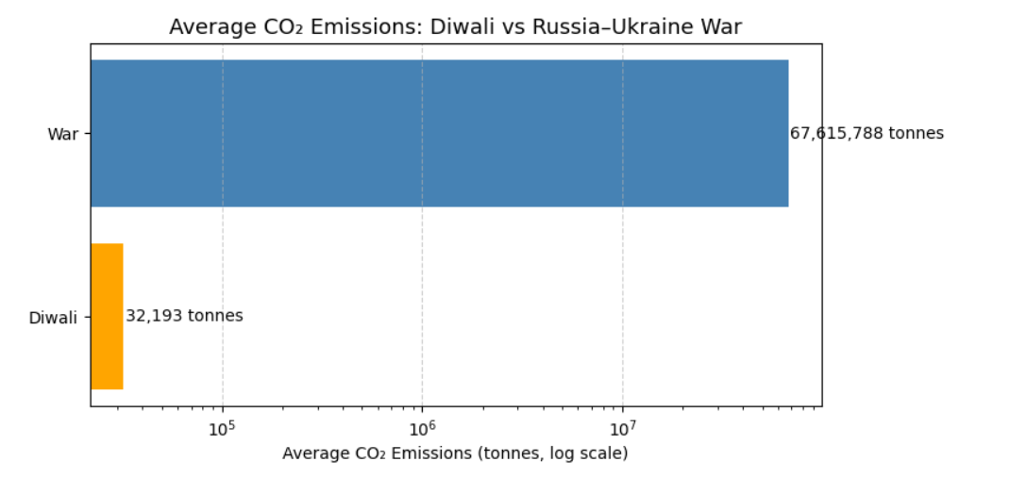
Observation:
- Despite the low percentage increase, the absolute average CO2 emissions from the War (67.6 million tonnes) are overwhelmingly greater than the emissions from Diwali (32.2 thousand tonnes).
- The log scale on the x-axis is necessary to visualize the difference, confirming that while Diwali is a sharp pollution shock, the War represents a catastrophic, high-magnitude environmental burden over its duration.

Insight 3: Spatial Distribution and Scale of PM2.5 Pollution
This combined analysis compares the spatial distribution and absolute magnitude of PM2.5 pollution across the most affected geographical areas for both events.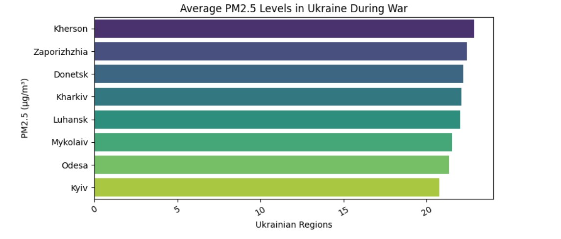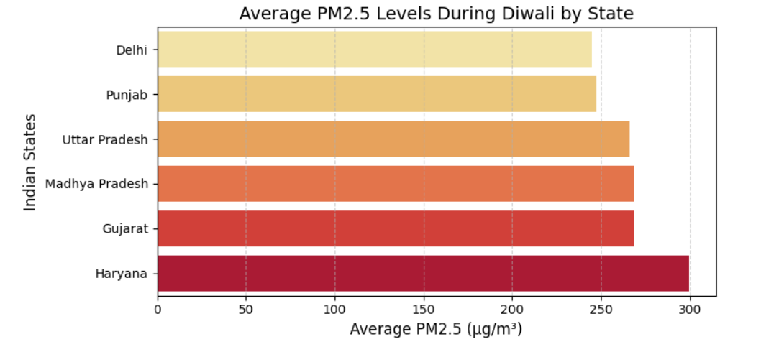
B. PM2.5 During War: Ukrainian Regions
Observation:
- PM2.5levels in Ukrainian regions are significantly lower in magnitude, peaking around 22 \mu g/m^3.
- The highest levels are seen in heavily conflicted regions like Kherson, Zaporizhzhia, and Donetsk, confirming the localized nature of PM2.5 pollution from combat (e.g., explosions and fires).
- Critically, the lowest PM2.5 levels during Diwali (230 \mu g/m^3) are over 10 times higher than the highest PM2.5 levels during the War (\sim 22\ \mu g/m^3).
A. PM2.5 During Diwali: Indian States
Observation:
- PM2.5 levels during Diwali are exceptionally high, with the top states registering averages well over 200\ \mu g/m^3.
- Haryana shows the highest average $\text{PM2.5}$ level, reaching nearly 300 \mu g/m^3.
- States like Uttar Pradesh, Madhya Pradesh, and Gujarat also show critically high concentrations (around 250-280\ mu g/m^3), demonstrating widespread severe air quality issues across Northern and Central India during the festival.

Insight 4: PM2.5 Levels Across Event Phases
This line plot visualizes the PM2.5 concentrations for both events across the "After," "Before," and "During" phases.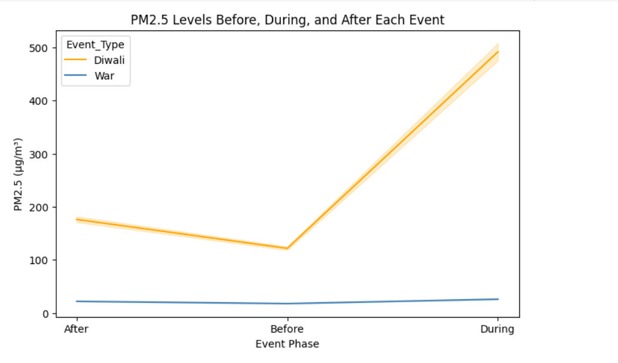 Observation:
- Diwali (Orange Line): The PM2.5levels spike drastically from approximately 120 \mu g/m^3 (Before) to nearly 500\mu g/m^3 (During), highlighting the immediate and severe impact on air quality. The levels are high even in the "Before" and "After" phases relative to the War.
- War (Blue Line): The PM2.5 levels are relatively stable and low across all phases, hovering around 20-30 \mu g/m^3. This confirms that while the War has a massive CO2 total, its PM2.5 impact is sustained but low-level compared to the high concentration of the Diwali event.

Summary of Key Insights
- Relative vs. Absolute Impact: Diwali is characterized by an extreme percentage increase in pollution (303.8% for PM2.5), reflecting a severe, short-term atmospheric shock. In contrast, the War represents a much larger absolute environmental crisis, with its average CO2 emissions (67.6 million tonnes) dwarfing those of Diwali (32.2 thousand tonnes).
- Pollutant Profile: The PM2.5 spike is the defining feature of Diwali, reaching nearly 500 \mu g/m^3 during the event phase. The War’s PM2.5 levels are low but sustained across phases, indicating a different profile of environmental harm.
- Spatial Distribution: War-related PM2.5 pollution is highly localized, with regions like Kherson, Zaporizhzhia, and Donetsk showing the highest average concentrations, consistent with areas of heavy combat.

Conclusion
The multi-phase analysis confirms that the type of event dictates the nature of the environmental impact. The Diwali festival, while brief, results in a devastating immediate health hazard due to the massive concentration of PM2.5 emissions. Conversely, the Russia-Ukraine War presents a vastly greater long-term global warming and environmental burden due to the astronomical CO2tonnage released over a prolonged period.
Recommendation
Future policy and environmental action should be dual-focused:
- Short-Term Mitigation: Implement and enforce strict regulations on firecrackers and open burning during cultural events like Diwali to rapidly reduce the peak PM2.5 health crisis.
- Long-Term Strategy: Acknowledge and quantify the catastrophic environmental cost of geopolitical conflicts. The millions of tonnes of CO2 from war must be factored into global carbon emission inventories and post-conflict environmental remediation efforts.

